Swale House, East Street,
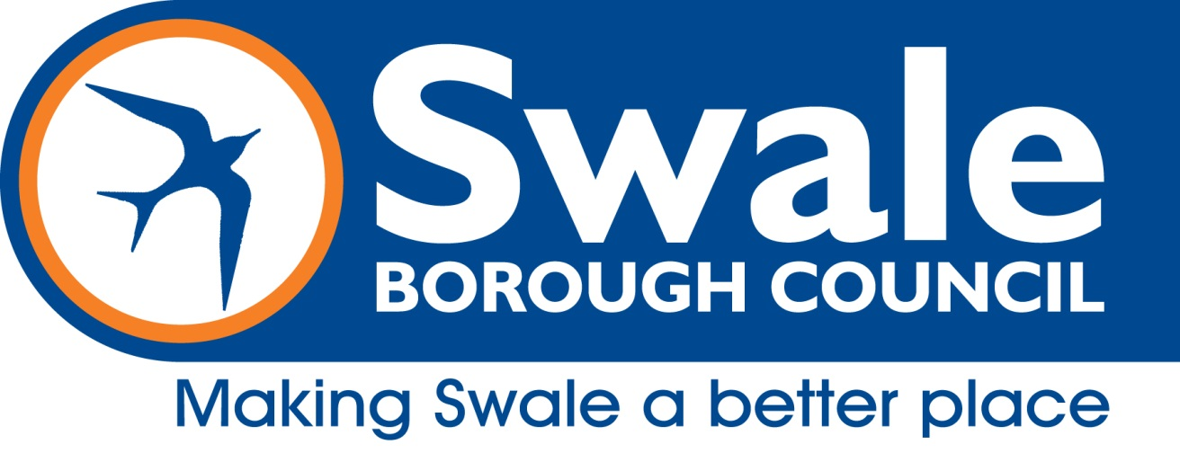
Sittingbourne, Kent ME10 3HT
DX59990 Sittingbourne 2
Phone: 01795 417567
www.swale.gov.uk

Licensing Act 2003

REPRESENTATION FORM FROM OTHER PERSONS
This representation is made by other persons of the premises to be licenced as detailed below:
Your name
Organisation name OR
Name of body you represent
Postal Address
Email address
Daytime contact number

Name of premises you are making a representation about
Address of premises you are making a representation about

Your representation must relate to one of the four licensing objectives (see note 4)
Licensing Objective | Yes/No | Please detail the evidence supporting your representation OR the reason for your representation. Please use a separate sheet of paper if necessary
Prevention of crime & disorder
Public Safety
Prevention of public nuisance
Protection of children from harm

SIGNED:
DATED:

NOTES:

- If you do make a valid representation you will be invited to attend a meeting of the Licensing Sub Committee and any subsequent appeal proceeding. If you do not attend, the Committee will still take into consideration any representations that you have made.

- This form MUST be returned within the Statutory Period, which is 28 days from the date the notice was displayed on the premises OR the date specified in the Public Notice in the newspaper.

- Representations can only relate to the four licensing objectives:
- Prevention of crime and disorder
- Public safety
- Prevention of public nuisance
- Protection of children from harm

- Your representation will be passed to the applicant, to allow them the opportunity of addressing your concerns. Your representations will be published in the report available to the Licensing Committee, which will be made public.

- Please note that the name and address (excluding house number) of any person that has submitted a representation will ordinarily be disclosed to the applicant and are a matter of public record. Swale Borough Council is unable to accept or take in to account any anonymous representations.

- Please return this form, when completed, to:
Licensing Section
Swale House
East Street
Sittingbourne
Kent
ME10 3HT
Or by Email to: licensing@swale.gov.uk

